An Overview and Advancement of Electricity Peak Load Saving Methods: A Review

Dr. A. Singaravelan, P.Sridharan

Department of EEE

New Horizon College of Engineering

Bangalore, India

[singaravelan@newhorizonindia.edu](mailto:singaravelan@newhorizonindia.edu)

Abstract— There are frequent peak demand occurring on the power system due to the growing energy needs of the world .This peak demand presents several issues which includes; imbalance in power between generations and load which tends to lower the power quality and stress to the system. Blackout, brownout, voltage instability, and surge/slack fluctuation occurs when the generated power is not matched with the required load demand. In addition to this, the Load Factor (LF) is inversely proportional to the peak demand thus, higher the peak demand, lower is the LF resulting in high energy cost. In order to meet out the daily peaks occurring on the power system, one of the viable solutions in the past was increasing the installed generation capacity or operating peaking plant . In this study, a detailed review was done to identify the latest technology to overcome the peak demand problems on power system. This study concludes that the peak demand can be efficiently controlled with a proper demand response program with the help of latest smart grid technology.

Index Terms—Demand Response, Smart-Grid, Peak-demand, Power System, Electricity

paper, some basic concepts of the smart grid are discussed initially and peak saving methods are added later.

The smart grid technology can make the conventional electrical grid into the modern grid with two-way communication and power flow. The smart grid technology can be implemented in several parts of the power systems like generation, transmission, and distribution. Both the consumer and the utility are economically benefited by converting the existing electric grid into the smart grid. The smart grid basic model is shown in figure 1 [2].

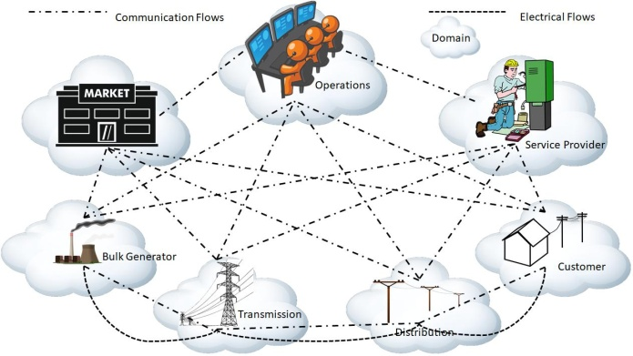

1. INTRODUCTION

The peaks occurring on the power system tend to be occasional and completely seasonal. Hence, adding a new power generation units to meet out the peak demand is very temporary result in reduced utilization factors; which in turn reduces the overall efficiency of the system. In addition, operating the peaking plant have many drawbacks like high operation/maintenance cost, the need of expensive fuel, plant equipment with a short lifespan and air pollution due to the emission of carbon dioxide(CO2) [1]. It is to overcome the drawback/s specified above there is a necessity to curtail the peak load to the possible extent by the effective handling of the demand side resources. This can be achieved by implementing peak saving methods which are discussed in this chapter.

Integration of Energy Storage System (ESS) to the grid, is one of the methods to save peak demand. During off-peak hours the ESS get a charge and during the peak demand occurs the charged power is fed back to the grid to adjusting the peak demand requirement. Even though this method save peak occurrence, but the large-scale installation of ESS is needed and its results with high capital investment. Also identifying the optimum size of ESS is again a big challenge because the random size of ESS will tend to wastage of unused size in ESS and loss of energy. Smart grid technology is one of the efficient ways to implement the peak saving method. In this

Fig. 1. Basic model of Smart grid

1. Different between existing grid and smart grid.: The operation control on the existing system was manual and it works based on electromechanical technique. In smart grid, the on/off control system for disconnection and connection of sup-ply for the grid is fully automated and it works based on digital control technique. The existing grid can communicate in only one direction but the smart grid can communicate in both direction (i.e.) it can communicate from utility to consumer and as well as consumer end to the utility. In an existing power system, the generation will be in one place or it is centralized. Due to this centralized power generation characteristic of the existing power system, the distance between from power plant and the consumer premise is very long. So due to this long-distance of the transmission line, there will be more power loss occurs. But in smart grid, due to the decentralized generation or distributed generation capability, this transmission loss can be reduced efficiently. Sensors for monitoring the health of the power system in the existing system is very limited whereas in the smart grid due to the smart communication and digital

control system, a maximum number of sensors can be installed to monitor all the working and fault status of the power system. The monitoring of fault and all status of the power system in the existing system is manual and its needed more human resources. In smart grid, the monitoring system is too easy and it has data logging capability. This data logging can be used to review the status for future analysis also. The power system will get affected largely when the disturbance occurs in the existing power system. But in smart grid technique, the fault occurred place is islanded automatically from the other grid; so that the fault will not affect in large. The recovery time in smart grid is very fast due the identifying the fault location in very short duration whereas in the existing system it will take more duration to identify the fault location.

1. Smart grid Components.: The main smart grid compo-nents are smart infrastructure, smart protection, smart commu-nication. The smart infrastructure can be classified into smart energy system and smart information system.

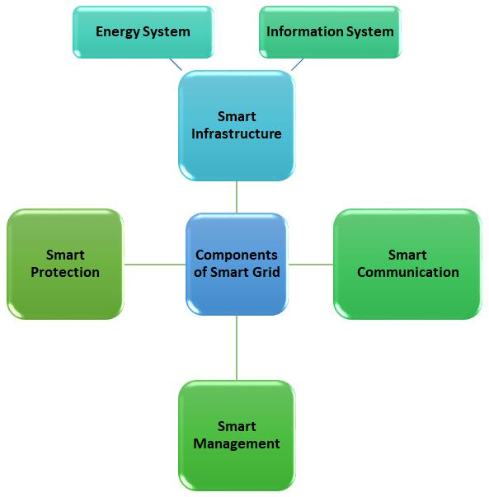

Fig. 2. Smart grid components.

1. Smart grid for customer domain: In the smart grid, the electricity is consumed in the customer domain. This domain will be bounded with consumer and the service provider for there communication flow and electricity flow. The consumer domain can be residential or industrial. The energy range for residential will be lesser than or equal to 20kW, for industrial its will greater than or equal to 200kW. The communication for the consumer domain includes Advance Metering Infras-tructure (AMI) with or without internet. The home appliances can be interconnected with sensors and relays to monitor and control. All the information from the home can be transmitted to the utility such that the consumption data, time of use of appliances, individual peak load. The consumer can get the cost of electricity from the utility with respect to different

Fig. 3. Smart energy system.

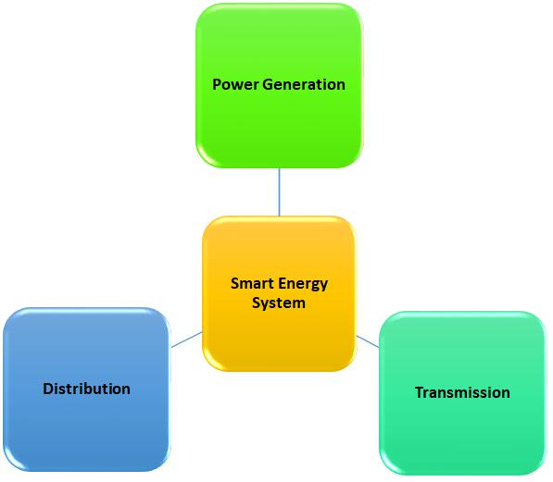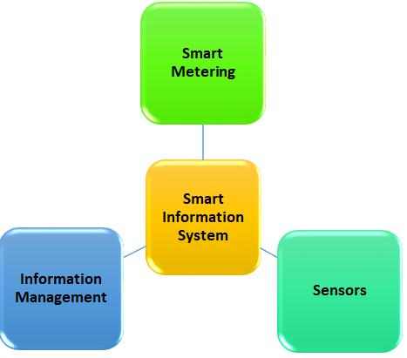

Fig. 4. Smart information system.

time slots. The consumer domain block diagram is shown in figure 5 and 6.

1. Smart grid for the market domain.: The utility assets are bought and sold by the market domain with the smart grid infrastructure. The market domain was central between the utility and the consumer. Power generation capacity and the consumer demand with different time slots were calculated by the market domain. The generation cost during peak time was high for the utility so the market domain need to given more money to buy the electricity from the utility and the same will replicate to the consumer. So, the electricity cost was decided by the market domain and the same will be communicated to the consumer. The consumer will have the details about the unit cost of electricity with the different time slot. Now the consumer has an option to reduce the usage of

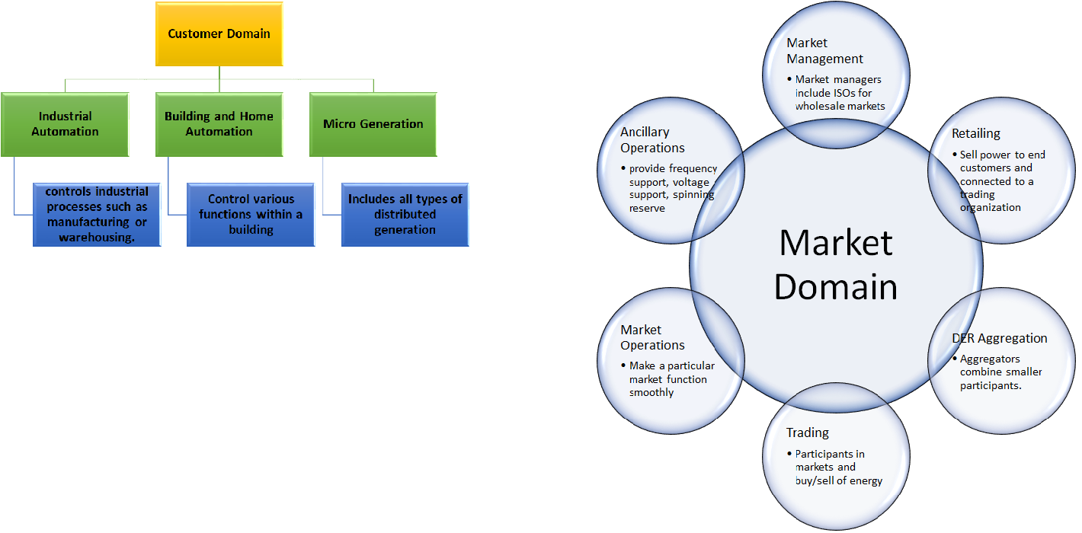

Fig. 5. Smart grid for consumer domain

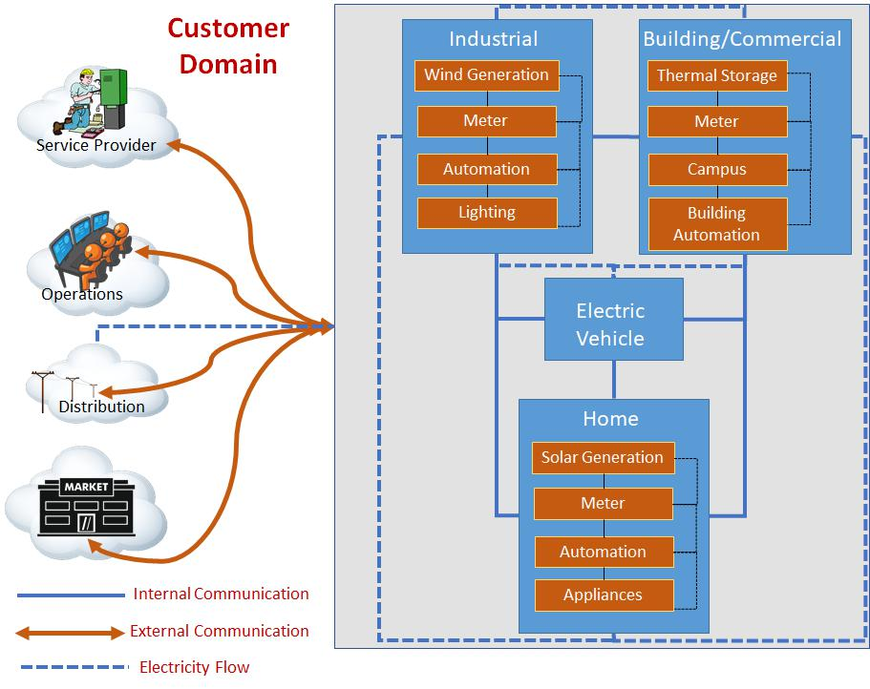

Fig. 7. Smart grid for market domain

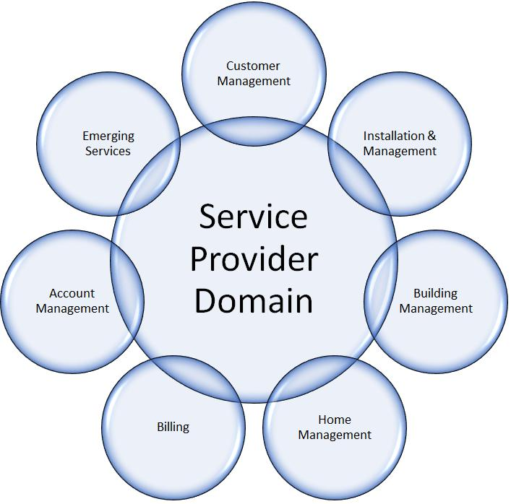

Fig. 6. Smart grid infrastructure with consumer domain

electricity during the high-cost time slot. But avoiding the use of electricity during the peak hours the utility need not spend more money for the generation of electricity. All this type of framing the cost of the electricity was decided by the market domain. Managing the big data with security and the timely communication between utility and consumer are some of the implementation challenges for the smart grid market domain.

1. Smart grid service provider domain.: The service providers will maintain the details about the existing consumer and record the details of the new consumer. The bill for all individual consumers is calculated and send it through the smart communication system. The consumer can contact the service provider in case of emergency. The electricity installation for the new consumer and the electricity mainte-nance for the existing consumer are taken care by the service provider. Electricity for buildings is maintained by monitoring and controlling of usage.
2. Smart grid for operation domain: Operation domain works towards the smooth operation of the power system. It will monitor all the network system for its status of the working condition. The operation domain will look for the fault that occurs in the network. The control of various operation level of the grid for its smooth operation is handled by the operation domain. The operation domain will log all the data about the system and generate the report of various

Fig. 8. Smart grid for market domain

performances and feedback of the system. The customer support and troubleshooting the consumer fault are done by the operation domain. Maintains the power grid for getting an uninterruptible power supply for the consumers. Constructs the power grids for newly developing area to give electricity to the consumer. Track the electricity usage patron of the consumer to make the decision for future power plant installation.

1. Smart grid for bulk generation domain.: The smart grid technology can handle the bulk generation assets effi-ciently by protecting the equipment from faults. Control and
2. Smart grid for transmission and distribution domain: The smart grid infrastructure can be implemented in trans-mission domain at substation, battery storage system and measurement/control. The automation control of bulk power flow at substation level can be achieved by the smart grid infrastructure. Remote monitoring and control of all substa-tion activities can be done. Communication system on the substation will be converted into digital system with real time data logging. Various sensors and activators are remotely monitored and controlled by the centre control system. Grid connected energy storage system can be efficiently controlled. The charging and discharging status of the battery can be remotely monitored.

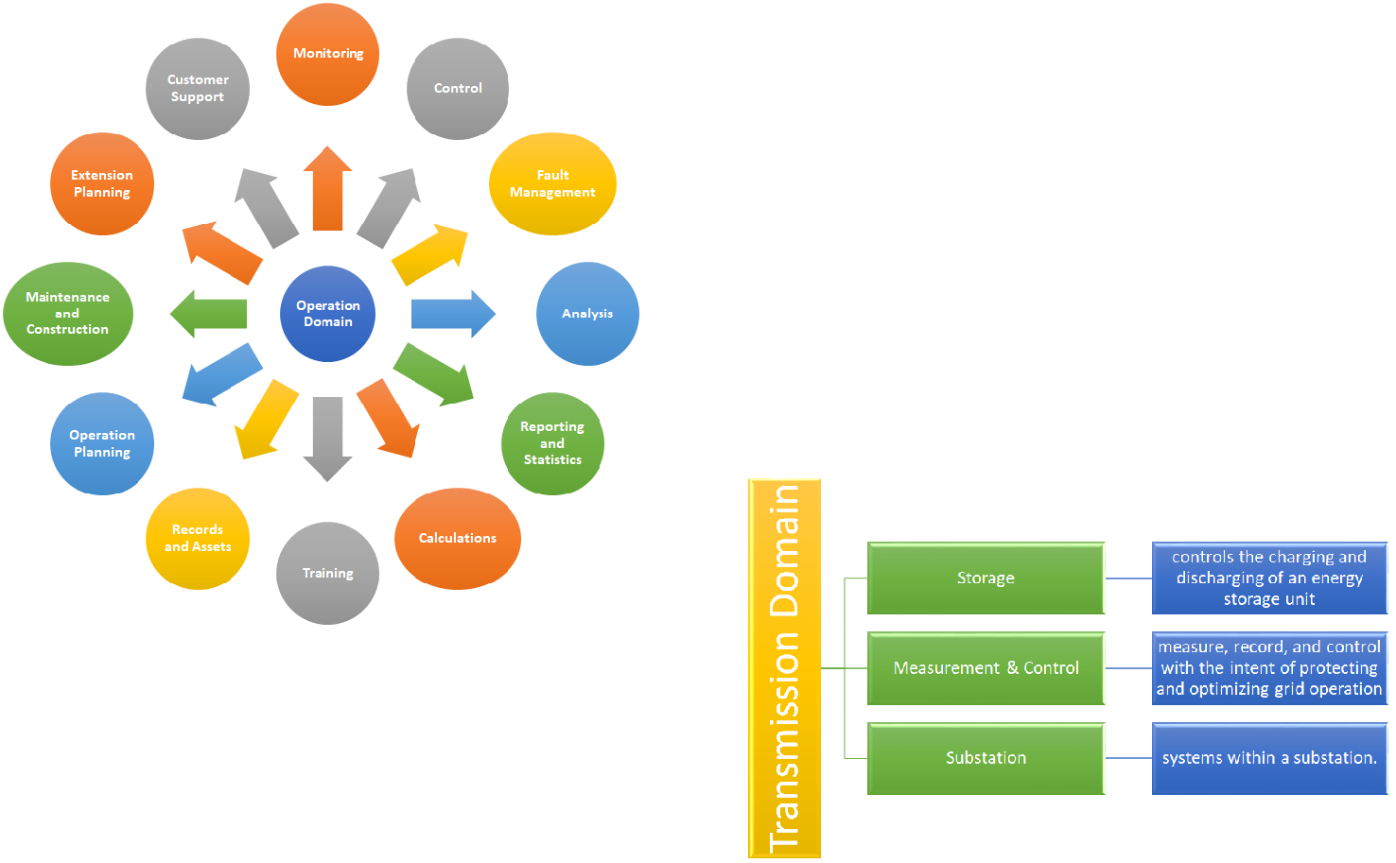

Fig. 9. Smart grid for operation domain

monitor of the generation equipment through digital system make the system smarter. Calculating the life span of the generation equipment can be simple with the smart grid infrastructure. Data logging on the generation system status is automated for forecasting purpose. The smart grid will protect the system from various unexpected fault occurrence. Measurement of all readings will be digitalised and the mea-sured data can be viewed through on-line. The power flow can be controlled through digital system which makes the system reliability stronger.

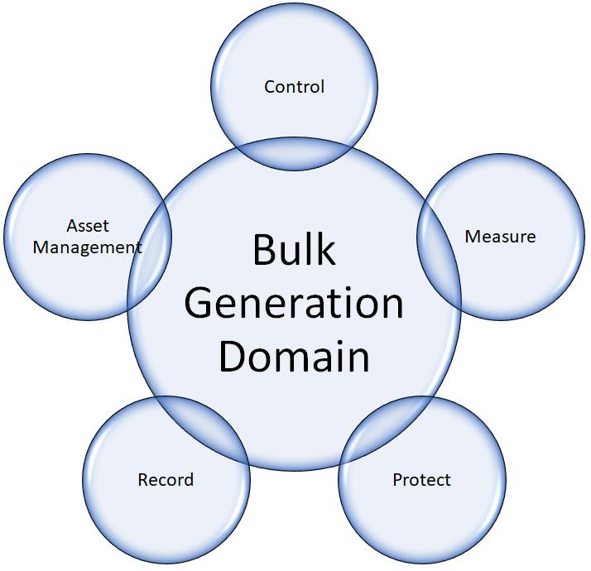

Fig. 11. Smart grid for transmission domain

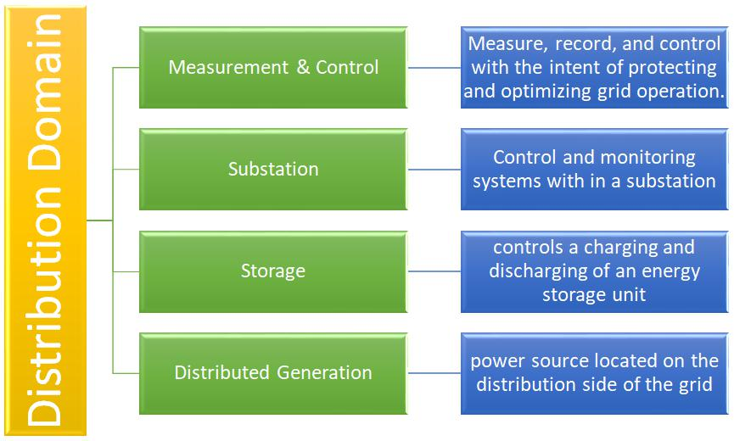

Fig. 12. Smart grid for distribution domain

The smart grid technology can able to enhance the tradi-tional power system into digitalised power grid. In this thesis, the author focused on smart grid technology for Demand Side Management with the aim of peak load reduction.

Demand Side Management (DSM) is one of the efficient method to reduce the peak demand. In this method, the peak demand is controlled at consumer premise. So the consumer will play an important role in reducing the peak demand. DSM program may inspire the consumers to use electricity efficiently for a reduction of energy consumption. In addition,

Fig. 10. Smart grid for bulk generation domain

DSM program may inspire the consumers to shift their load

from peak hours to off-peak hours by considering an attractive

and profitable scheme. DSM can be classified into two types [3].

Energy Efficiency (EE)

Demand Response (DR)

* + 1. DEMAND SIDE MANAGEMENT

1. Energy Efficiency

The Energy Efficiency methods are basically implemented while constructing a building itself and it is a long-term process with an aim of reducing the power consumption.

1. can be implemented by advising the consumer to follow the EE standards, codes and guidelines while construction of their new building. The government of India, Ministry of Power and Bureau of Energy Efficiency issued the Energy Conservation act 2001 with an aim of energy saving [4]. This act contains the details about to follow the standards and guidelines for choosing and installation of the home appliances and electrical equipment for consumers with an aim of efficient utilization of electrical energy. The codes for new buildings are given in Energy conservation building code (ECBC) the major components which are addressed in this code are building envelope, lighting system, HVAC system, water heating, and pumping system and electrical power system. In recent, many researchers concentrating on designing modern EE methods like Home Automation System (HAS), Energy Saving Smart Sockets (ESSS) and Standby power saving system.

In late 1994 it is believed that the consumers electricity consumption is reduced by providing information about their instantaneous consumed cost with the help of smart meters. Harold Wilhite and Rich Ling conducted a three-year investi-gation on the relationship between displaying instant electric-ity bill to consumers and changes in electricity consumption [5]. In the third year of investigation, results show a positive sign with a 10% of the reduction in electricity consumption. Three different groups of Electrical Energy Conservation (EEC) technologies are investigated in [6] namely; EEC on electrical equipment, EEC on buildings, EEC supporting tools. With this three methods, a 25% of electric power consumption can be efficiently saved. An online electricity consumption information system was proposed with an aim of encouraging the consumer for involving in EEC method [7]. This method was implemented in 10 houses for a period of nine months. The overall result shows that the power consumption is re-duced by 18% after implementing this method.

B. Demand Response

Demand response programs mainly used for peak saving on the power system at consumer premise. The objective of the demand response program is to encourage or motivate the consumer to reduce the usage of electricity during peak hours by providing a profitable scheme to them. The consumer may shift the time of using their electrical load with respect to the price signal forecasted by the utility. The demand response can be efficiently implemented with smart grid infrastructures like smart meter, two-way communication of power system,

wireless home area network and sensor area network. Many re-searchers have focused on practical implementation of demand response program with the help of smart grid technologies.

The demand response program can be classified into two types,

Incentive-Based Demand Response (IBDR)

Price-Based Demand Response (PBDR)

1. Incentive-based demand response: In the IBRD pro-gram, the consumer will get payment offers from electricity providers when they reduce their electricity usage during peak hours.

The IBDR can be classified into three types,

Direct Load Control(DLC)

Curtailable Load (CL)

Demand Side Bidding (DSB)

* 1. Direct Load Control: DLC program is mainly focused on residential consumers. In this program, the consumer who participating will make a contract sign with the utility. In the contract, the consumer will accept to control their load to turn ON/OFF by the utility during the peak hours. In return, the utility will give intensives like reduction in the cost of the consumers monthly bill or cash reward. The consumers can break the rule if they feel more discomfort, but they need to pay the penalty to the utility. The most acceptable electrical load for this program is Air Conditioning (AC) system and sometimes loads like a water heater, pool pump is considered for DLC program. DLC program can be implemented with less investment and no need for higher technology [8]
  2. Curtailable Load: CL is similar to DLC but the only difference is, the consumer need to manually reduce their electric load during peak hours to reduce their consumption cost. The contract between utility and consumer will be same as DLC. The consumer should operate their load within the acceptable level on peak hours. The incentive and penalty will be the same as DLC. The implementation cost for CL is low and no need for high-end technology [8]
  3. Demand Side Bidding: DSB program will offer the consumer to participate in the electricity market. The consumer will send their demand reduction bids to the utility. The bids will state the information about the consumer willing to reduce their electrical load and required a cost for it. The utility will verify the bids and allow once they satisfied with the applied bits. This method needs more participation of consumer and needs some communication technology to implement [9]

2) Price-Based Demand Response: In PBDR, the utility will make a contract with their consumer for time-variant traffic scheme. Consumers need to pay more during peak hour consumption and low during off-peak hours. With this scheme, the consumer will get periodic notification from the utility of different electricity cost with respect to time. The notification may be forecasted to consumers by weekly or day-ahead or hourly basis. The consumer can able to plan for changes to their electricity consumption pattern with respect to the updated traffic notification with an aim of economic profit. The more economic saving by the consumer will reflect

a reduction in peak demand for the power system. In this program, consumers are allowed to make a decision about to turn on/off their electrical load during peak hours as per their comfort level.

Time of Use (ToU)

Critical-peak price (CPP) Real-time price (RTP)

1. Time of Use (ToU): Per day pricing variation under the ToU scheme will be very less when compared to RTP. Only a few steps price variation will be occurred in the ToU based on power demand during peak, off-peak and shoulder hours. During peak hours the cost of electricity consumption is high and low during off-peak hours. During shoulder hours the cost will be moderate. The day to day variation of ToU rated scheme will not change frequently [8].
2. Critical-peak price (CPP): The CPP is an alternative program of ToU, but the information of variation in electricity cost will be incertitude for the consumer. The utility may face sudden or uncertain peak demand. During this uncertain peak hours, there may be an increase in consumption cost with a short notification to the consumer. This CPP program can be applied for all consumer with irrespective of a load size of the consumer [8]
3. Real-time price (RTP): Immediate demand response can be achieved effectively by implementing the RTP program. With respect to the measured instantaneous power demand of the system, the time-based price is calculated by utility [11], [12]. The consumer will get a notification about this real-time price details by day-ahead or hourly basis. With the information of real-time price, the consumer may reflect by reducing the usage of electricity during high-cost hours. This real-time response by the consumer will maintain the stability of the power system and economic profit. Implementation of RTP needs modern digital infrastructure and bidirectional communication between consumer and utility. Smart grid technologies will be the solution for the need of RTP program implementation.

Game theory based automatic appliances scheduling method was proposed in [13]. This method consists of a two-way communication system for interaction between utility and consumer. The proposed algorithm schedules the appliances with respect to real-time price information. The results show a profitable saving in cost of consumed power. The practical implementation model for automatic scheduling of air con-ditioner with respect to real-time price and temperature was proposed by Zeeshan [14]. Cost reduction architecture was introduced in this method and the results prove the during peak hours the load is turned off automatically by considering the consumer comfort. Real-time price based optimal scheduling scheme was proposed by Muhammad Awais . This proposed work schedule the appliances with a delay during peak hour and results in an economic saving of consumer electricity consumption.

1. USEFUL OUTCOME OF REVIEW

From the literature review, it is found that the RTP demand response program will efficiently save the peak demand and consumption cost. Demand response program can be imple-mented at consumer premise with a HEM algorithm and smart grid infrastructure.

Almost no studies in the literature provide a HEM algo-rithm by considering about 100% of task completion of the appliances during load scheduling with an aim of reduction in peak demand and consumption cost.

HEM with considering both consumer comfort level and reduction in peak demand was not available in the literature.

Most of the HEM methods in literature are based on an evolutionary algorithm, which makes the system complex and its effect the system response time.

Few researchers proposed a conventional voltage control method in HEM for load saving, but there is no any real-time experiment on home appliances is done to test the efficiency of this method.

Implementation of the smart plug is found to be an efficient way for HEM methods. But the capital cost is high with smart plugs, so low-cost hardware design for the smart plug is needed.

Standby power loss is found to a long-term power wastage. Some researcher brings out this issue and contributes their standby power saving methods. But, a combination of the smart plug with the standby power saving method is not available in the literature.

REFERENCES

1. Uddin, M., Romlie, M. F., Abdullah, M. F., Abd Halim, S., Abu Bakar, A. H. and Chia Kwang, T. (2018), A review on peak load shaving strategies, Renewable and Sustainable Energy Reviews 82(February 2017), 33233332.
2. Office of the National Coordinator for Smart Grid Interoperability (2010), NIST Framework and Roadmap for Smart Grid Interoperability Standards, pp. 190.
3. Alasseri, R., Tripathi, A., Joji Rao, T. and Sreekanth, K. J. (2017), A re-view on implementation strategies for demand side management (DSM) in Kuwait through incentivebased demand response programs, Renew-able and Sustainable Energy Reviews 77(December 2015), 617635.
4. Overview Government of India Ministry of Power (n.d.).
5. Wilhite, H. and Ling, R. (1995), Measured energy savings from a more informative energy bill, Energy and Buildings 22(2), 145155.
6. Alajlan, S., Smiai, M. and Elani, U. (1998), Effective tools toward electrical energy conservation in Saudi Arabia, Energy Conversion and Management 39(13), 1337 1349.
7. Ueno, T., Inada, R., Saeki, O. and Tsuji, K. (2006), Effectiveness of an energy consumption information system for residential buildings, Applied Energy 83(8), 868 883.
8. Rocky Mountain Institute (2006), Demand Response: An Introduction Overview of Programs, Technologies, and Lessons Learned, p. 46.
9. Siano, P. (2014), Demand response and smart grids - A survey, Renew-able and Sustainable Energy Reviews 30, 461478.
10. Iwafune, Y., Mori, Y., Kawai, T. and Yagita, Y. (2017), Energy-saving effect of automatic home energy report utilizing home energy management system data in Japan, Energy 125, 382392.
11. Yu, R., Yang, W. and Rahardja, S. (2012), A statistical demand-price model with its application in optimal real-time price, IEEE Transactions on Smart Grid 3(4), 1734 1742.
12. Weckx, S., Driesen, J. and DHulst, R. (2013), Optimal real-time pricing for unbalanced distribution grids with network constraints, IEEE Power and Energy Society General Meeting .
13. Mohsenian-Rad, A. H., Wong, V. W., Jatskevich, J., Schober, R. and Leon-Garcia, A. (2010), Autonomous demand-side management based on game-theoretic energy consumption scheduling for the future smart grid, IEEE Transactions on Smart Grid 1(3), 320331.
14. Haider, Z., Mehmood, F., Guan, X., Wu, J., Liu, Y. and Bhan, P. (2015), Scheduling of air conditioner based on real time price and real-time temperature, Proceedings of the 2015 27th Chinese Control and Decision Conference, CCDC 2015 pp. 51345138.